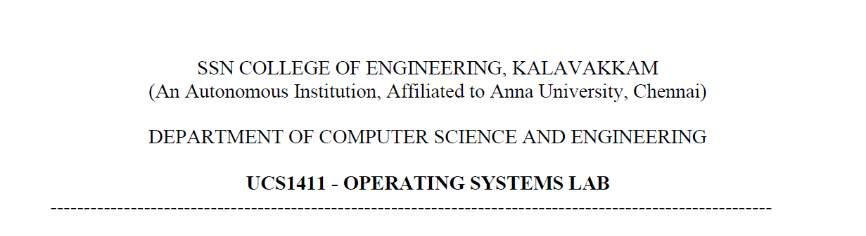

**LAB EXERCISE 2**

**Implementation of System calls**

**Submission Date:16-03-2022**

Name: Jayannthan P T

Dept: CSE ‘A’

Roll No.: 205001049

Implementing cp command in C using system calls

**Algorithm:**

1. If argc greater than 4, then print error : too many arguments
2. Else if argc is lesser than 2, then print error :more arguments required
3. Else
   1. Open file using call open() using filename as argument provided in read-only mode and store the file pointer in file_descriptor1
   2. If file_descriptor1 is equal to -1 then print error and exit
   3. Else then read the contents using call read() and store the return value in contents
   4. Close the file
   5. If “i” is present in argument then
      1. Create a file using creat() and store the file pointer in file_ descriptor2
      2. If file_ descriptor2 is equal to -1 then print error and exit
      3. Write the “contents” into file_ descriptor2 using write() call
      4. Close the file
   6. Else then
4. Open a file using open() and store the file pointer in file_ descriptor2
5. If file_ descriptor2 is less than 0 then prompt for overwrite
   * If answer is yes overwrite in the same file
   * Else create new file and write the contents into it
6. Else then create new file and write the contents into it

**Code:**

#include <stdio.h>

#include <stdlib.h>

#include <string.h>

#include <unistd.h>

#include <fcntl.h>

**int** main(**int** argc, **char** *argv**[]**)

{

    if (argc > 4)

        printf("Too many arguements\n");

    else if (argc < 2)

        printf("Atleast Two arguements required\n");

    else

    {

        printf("Opening file1:\n");

**int** file_descriptor1 = open(argv[1], O_RDONLY);

        if (file_descriptor1 == -1)

            printf("Source File does not exist\n");

        else

        {

**char** contents[100];

            printf("Reading file1:\n");

**int** re = read(file_descriptor1, contents, 100);

            printf("Checking for i:\n");

            if (argc > 3 && strcmp(argv[3], "i") == 0)

            {

                printf("Found i:\n");

                printf("Creating file2:\n");

**int** file_descriptor2 = creat(argv[2], S_IRUSR | S_IWUSR);

                if (file_descriptor2 < 0)

                {

                    printf("!!!ERROR!!!\n");

                }

                else

                {

                    printf("copying into file2:\n");

**int** wr = write(file_descriptor2, contents, sizeof(contents));

                    printf("Closing file2:\n");

                    close(file_descriptor2);

                    printf("\nSuccessfully Copied\n");

                }

                close(file_descriptor1);

            }

            else

            {

                printf("i not found:\n");

                printf("Checking file2:\n");

**int** file_descriptor2 = open(argv[2], O_WRONLY);

                if (!(file_descriptor2 < 0))

                {

**char** ch;

                    printf("Overwrite %s file?(y/n) ", argv[2]);

                    scanf(" %c", &ch);

                    if (!(ch == 'y' || ch == 'Y'))

                    {

                        close(file_descriptor2);

                        close(file_descriptor1);

                    }

                    else

                    {

                        printf("Creating file2:\n");

**int** file_descriptor2 = creat(argv[2], S_IRUSR | S_IWUSR);

                        if (file_descriptor2 < 0)

                        {

                            printf("!!!ERROR!!!\n");

                        }

                        else

                        {

                            printf("writing into file2:\n");

**int** wr = write(file_descriptor2, contents, sizeof(contents));

                            close(file_descriptor2);

                            printf("\nSuccessfully Copied\n");

                        }

                        close(file_descriptor1);

                    }

                }

                else

                {

                    printf("Creating file2:\n");

**int** file_descriptor2 = creat(argv[2], S_IRUSR | S_IWUSR);

                    if (file_descriptor2 < 0)

                    {

                        printf("!!!ERROR!!!\n");

                    }

                    else

                    {

                        printf("copying into file2:\n");

**int** wr = write(file_descriptor2, contents, sizeof(contents));

                        printf("Closing file2:\n");

                        close(file_descriptor2);

                        printf("\nSuccessfully Copied\n");

                    }

                    close(file_descriptor1);

                }

            }

        }

    }

    return 0;

}

**Output:**

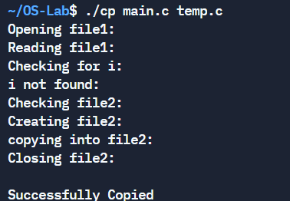 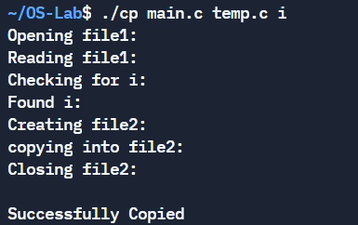 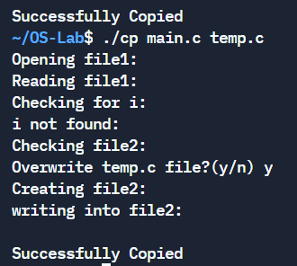

Implementing ls command in C using system calls

**Algorithm:**

1. If argc greater than 4, then print error: too many arguments
2. Else if argc is lesser than 1, then print error:more arguments required
3. Else if argc is equal to 2
   1. Open directory using call opendir() using directory-name as argument provided and store the file pointer in dir
   2. If dir is null then print error and exit
   3. Else display the names of all files and directories with name not starting with “.”
   4. Close the pointer dir
4. Else If “r” is present in argument then
   1. Open directory using call opendir() using directory-name as argument provided and store the file pointer in dir
   2. If dir is null then print error and exit
   3. Else display the names of all files and directories with name recursively
   4. Close the pointer dir
5. Else If “a” is present in argument then
   1. Open directory using call opendir() using directory-name as argument provided and store the file pointer in dir
   2. If dir is null then print error and exit
   3. Else display the names of all files and directory name
   4. Close the pointer dir

**Code:**

#include <stdio.h>

#include <stdlib.h>

#include <unistd.h>

#include <dirent.h>

#include <fcntl.h>

DIR *dir, *temp;

**struct** dirent *tmp;

**void** recursive(**struct** dirent *entry)

{

    if (entry == NULL)

    {

        return;

    }

    recursive(readdir(dir));

    printf("  %s\n", entry->d_name);

}

*// void normal(struct dirent *entry, int n)*

*// {*

*//     if (entry == NULL)*

*//     {*

*//         return;*

*//     }*

*//     for (int i = 0; i < n; i++)*

*//     {*

*//         printf("\t");*

*//     }*

*//     printf("  %s\n", entry->d_name);*

*//     if (entry->d_type == DT_DIR && !(strcmp(entry->d_name, ".") == 0 || strcmp(entry->d_name, "..") == 0 || (entry->d_name[0] == '.')))*

*//     {*

*//         temp = opendir(entry->d_name);*

*//         tmp = readdir(temp);*

*//         normal(&tmp, n + 1);*

*//         closedir(temp);*

*//     }*

*//     normal(readdir(dir), n);*

*// }*

**int** main(**int** argc, **char** *argv**[]**)

{

    if (argc > 4)

        printf("Too many arguements\n");

    else if (argc < 1)

        printf("Atleast one arguement required\n");

    else

    {

*// printf("%d\n",argc);*

        if (argc == 2)

        {

**struct** dirent *entry;

            if ((dir = opendir(argv[1])) == NULL)

            {

                printf("CANNOT OPEN GIVEN DIRECTORY");

            }

            else

            {

                printf("Contents of the given:\n");

                while ((entry = readdir(dir)) != NULL)

                {

                    if (strcmp(entry->d_name, ".") == 0 || strcmp(entry->d_name, "..") == 0 || (entry->d_name[0] == '.'))

                        continue;

                    printf("  %s\n", entry->d_name);

                }

                closedir(dir);

            }

        }

        else if (argc > 1 && strcmp(argv[2], "r") == 0)

        {

            printf("ls -R\n");

**struct** dirent *entry;

            if ((dir = opendir(argv[1])) == NULL)

            {

                printf("CANNOT OPEN GIVEN DIRECTORY");

            }

            else

            {

                printf("Contents of the given:\n");

                recursive(&entry);

                closedir(dir);

            }

        }

        else if (argc > 1 && strcmp(argv[2], "a") == 0)

        {

*// DIR *dir;*

**struct** dirent *entry;

            if ((dir = opendir(argv[1])) == NULL)

            {

                printf("CANNOT OPEN GIVEN DIRECTORY");

            }

            else

            {

                printf("Contents of the given:\n");

                while ((entry = readdir(dir)) != NULL)

                {

                    printf("  %s\n", entry->d_name);

                }

                closedir(dir);

            }

        }

*// else if (argc > 1 && strcmp(argv[2], "R") == 0)*

*// {*

*//     // DIR *dir;*

*//     struct dirent *entry;*

*//     if ((dir = opendir(argv[1])) == NULL)*

*//     {*

*//         printf("CANNOT OPEN GIVEN DIRECTORY");*

*//     }*

*//     else*

*//     {*

*//         printf("Contents of the given:\n");*

*//         if ((entry = readdir(dir)) != NULL)*

*//         {*

*//             normal(&entry, 0);*

*//         }*

*//         closedir(dir);*

*//     }*

*// }*

    }

    return 0;

}

**Output:**

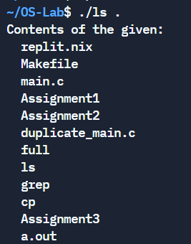 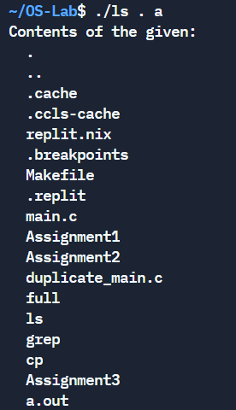 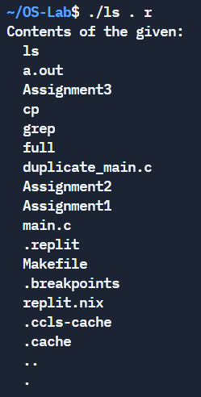

Implementing grep command in C using system calls

**Algorithm:**

1. If argc greater than 4, then print error: too many arguments
2. Else if argc is lesser than 2, then print error:more arguments required
3. Else if
   1. Open file using call open() using filename as argument provided in read-only mode and store the file pointer in file_descriptor
   2. If file_descriptor is equal to -1 then print error and exit
   3. Else then read the contents using call read() and store the return value in buf
   4. Close the file
   5. If argc is equal to 3 then
      1. Iterate through the buf and store each line in line
      2. Check for the input expression in line
      3. If it is present then display
   6. Else If “c” is present in argument then
      1. Iterate through the buf and store each line in line
      2. Check for the input expression in line
      3. If it is present then increment the count value
      4. Display count

**Code:**

#include <stdio.h>

#include <stdlib.h>

#include <unistd.h>

#include <string.h>

#include <dirent.h>

#include <fcntl.h>

**int** main(**int** argc, **char** *argv**[]**)

{

    if (argc > 4)

        printf("Too many arguements\n");

    else if (argc < 2)

        printf("Two arguements required\n");

    else

    {

**int** file_descriptor = open(argv[2], O_RDONLY);

        if (file_descriptor == -1)

            printf("File does not exist\n");

        else

        {

            if (argc == 3)

            {

*// printf("Normal Grep\n");*

**char** line[100], buf[1024];

**int** l = 0, i = 0, nr, count = 0;

                nr = read(file_descriptor, buf, 1024);

                close(file_descriptor);

                while (l < nr)

                {

                    for (i = 0; buf[l] != '\n' && l < nr; i++, l++)

                    {

                        line[i] = buf[l];

                    }

                    line[i] = '\0';

                    l++;

                    if (strstr(line, argv[1]))

                        printf("%s\n", line);

                }

            }

            else if (argc > 3 && strcmp(argv[3], "c") == 0)

            {

*// printf("Grep -c\n");*

**char** line[100], buf[1024];

**int** l = 0, i = 0, nr, count = 0;

                nr = read(file_descriptor, buf, 1024);

                close(file_descriptor);

                while (l < nr)

                {

                    for (i = 0; buf[l] != '\n' && l < nr; i++, l++)

                    {

                        line[i] = buf[l]; *// extracting lines*

                    }

                    line[i] = '\0';

                    l++;

                    if (strstr(line, argv[1]))

                    {

                        count++;

                    }

                }

                printf("%d\n", count);

            }

        }

    }

    return 0;

}

**Output:**

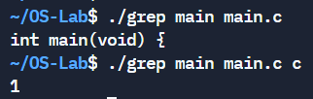

**Learning Outcome:**

* Implemented various system commands in C using system calls
* Learned to handle system calls in C program